

**Technical Information for Upland Game Rule Development**

Survey and Harvest Data

Upland game management in New Mexico is centered on monitoring harvest and population trends, and status reports from hunters and field staff.

**Population Monitoring**

Upland species population trends often follow weather patterns, with populations increasing in years with good environmental conditions and declining during bad years (Campbell et al 1973).

The Department does not have a long-term monitoring data set for upland species in the state. For quail, call count and fall breeding productivity surveys have been initiated by the Department. Call counts and roadside surveys are common methods used for assessing quail population trends (Rollins et al. 2005). These techniques can be used to monitor trends at ecoregional scales. Data from the Department’s spring call count survey can be found in Table 1. Data from fall roadside brood surveys can be found in Table 2.

Table 1. Data from the Department’s spring call count survey.

|  |  |  |  |  |  |  |  |  |  |  |  |  |  |  |  |
| --- | --- | --- | --- | --- | --- | --- | --- | --- | --- | --- | --- | --- | --- | --- | --- |
|  | **Plains and great basin grasslands** | | | | | **Semi-desert grasslands** | | | | | **Chihuahuan desert scrub** | | | | |
| **2024** | **2023** | **2022** | **2021** | **2020** | **2024** | **2023** | **2022** | **2021** | **2020** | **2024** | **2023** | **2022** | **2021** | **2020** |
| Total Stops | 146 | 161 | 166 | 128 | 128 | 309 | 318 | 340 | 320 | 280 | 187 | 190 | 186 | 189 | 189 |
| Stops with Birds | 66 | 77 | 53 | 40 | 76 | 126 | 190 | 97 | 139 | 159 | 66 | 98 | 40 | 37 | 86 |
| Total Calls | 1,246 | 1,481 | 787 | 139 | 909 | 1,619 | 3,504 | 1,301 | 938 | 2,219 | 701 | 1,609 | 314 | 233 | 925 |
| Avg Calls @ stops w/Birds | 18.9 | 19.2 | 14.8 | 3.5 | 12.0 | 12.8 | 18.4 | 13.4 | 6.7 | 14.0 | 10.6 | 16.4 | 7.9 | 6.3 | 10.8 |
| Total Birds | 211 | 217 | 188 | 61 | 196 | 301 | 493 | 247 | 238 | 410 | 126 | 236 | 59 | 58 | 211 |
| Avg. Calls/bird | 5.9 | 6.8 | 4.2 | 2.3 | 4.6 | 5.4 | 7.1 | 5.3 | 3.9 | 5.4 | 5.6 | 16.4 | 7.9 | 4.0 | 4.4 |

Table 2. Data from the Department’s fall roadside quail brood survey.

|  |  |  |  |  |  |  |  |  |  |  |  |  |  |  |
| --- | --- | --- | --- | --- | --- | --- | --- | --- | --- | --- | --- | --- | --- | --- |
|  | **Quail Detections** | | | | | | | **Quail Per Mile** | | | | | | |
| **Habitat Type** | **2024** | **2023** | **2022** | **2021** | **2020** | **2019** | **2018** | **2024** | **2023** | **2022** | **2021** | **2020** | **2019** | **2018** |
| Plains and great basin grasslands | 20 | 22 | 33 | 16 | 20 | 34 | 44 | 1.5 | 2.9 | 1.6 | 0.5 | 0.8 | 1.2 | 1.2 |
| Semi-desert grasslands | 44 | 45 | 24 | 29 | 86 | 33 | 37 | 0.8 | 1.5 | 0.7 | 0.6 | 3.2 | 1.2 | 1.0 |
| Chihuahuan desert scrub | 12 | 52 | 13 | 15 | 25 | 19 | 25 | 0.3 | 1.2 | 0.7 | 0.4 | 2.0 | 0.8 | 0.4 |

The Breeding Bird Survey (BBS) can be used to understand statewide changes in bird populations and distribution. The BBS is an annual survey, where surveyors collect bird observation data along established roadside routes during June when birds are vocalizing breeding calls (Sauer et al. 2013). BBS data can be used to summarize population change and relative species abundance (Sauer et al. 2013). BBS population trends for northern bobwhite, scaled quail, and Gambel’s quail in New Mexico can be found in Figure 1. Because routes are lacking in Montezuma quail and dusky grouse range, these species populations trends cannot be modeled with BBS data.

Figure 1. BBS trend data for northern bobwhite, scaled quail, and Gambel’s quail in New Mexico.

There is not a similar monitoring program for tree squirrels. In New Mexico, tree squirrel monitoring centers on harvest monitoring and field reports from hunters, citizens, and Department personnel.

**Harvest monitoring**

Upland game harvest management focuses on harvest limits that provide sufficient opportunity while leaving ample individuals on the landscape for the following breeding season (Peterson 2001). Previous research on small game suggested harvest has little to no effect on annual population survival (Errington and Hamerstrom 1935), but more recent studies have shown that hunting mortality can increase local population mortality rates but likely does not impact numbers at a statewide level (Pollock et al. 1989, Brennan et al. 2014). It is unlikely that harvest mortality brings about signification reduction in statewide small game numbers due to their high reproductive potential and large areas of inaccessible and refuge habitat in New Mexico. In addition, small game hunters will regulate themselves to a degree. New Mexico hunter effort follows this trend (Figures 2 and 3). When upland populations are higher reported hunter participation and harvest rates are higher. Conversely when upland populations are lower, fewer hunters report hunting, though hunters that do go during these times are likely more skilled in upland hunting (Guthery et al. 2004).

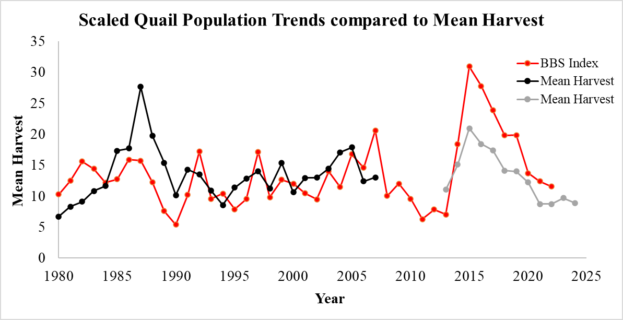

Figure 2. BBS population trends for scaled quail compared to the mean reported harvest

All quail harvest was combined until 1991-92. After that, harvest reporting was separated out by species. Mean harvest in black is data from paper mail harvest surveys. Mean harvest in gray is data from voluntary online harvest reporting.

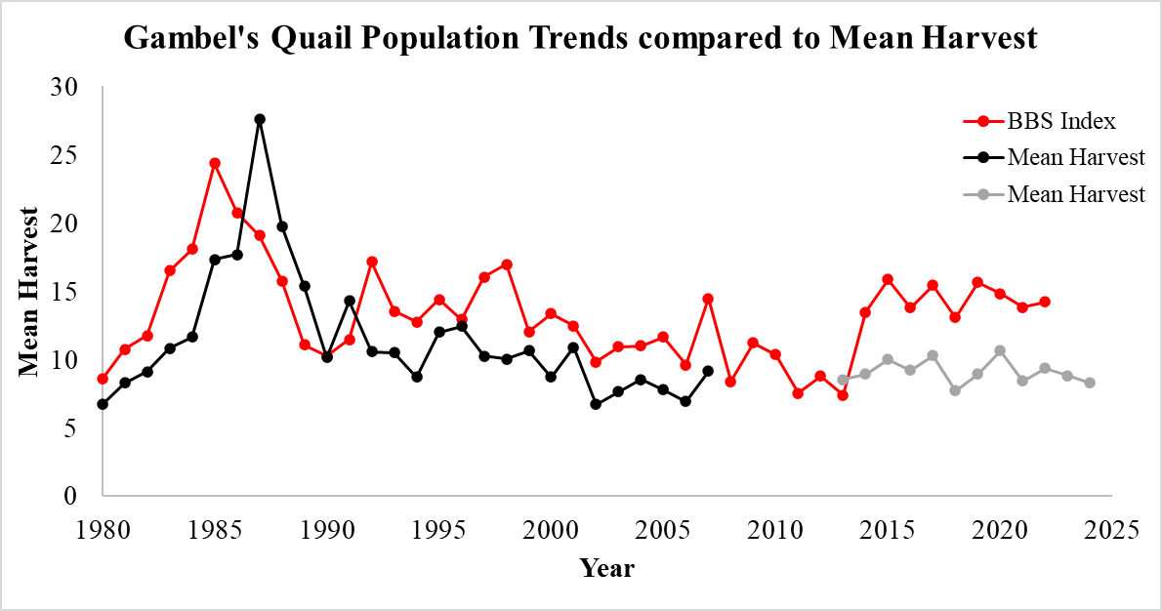

Figure 3. BBS population trends for Gambel’s quail compared to the mean reported harvest

All quail harvest was combined until 1991-92. After that, harvest reporting was separated out by species. Mean harvest in black is data from paper mail harvest surveys. Mean harvest in gray is data from voluntary online harvest reporting.

Submission of a harvest report is voluntary. License holders are able make submissions through the Department’s online Harvest Reporting System or by phone. For licenses holders who submit a report, information is collected on if they hunted, what species was harvested, the number harvested, and the county of harvest. Hunters may report hunting in multiple counties. Harvest information of upland game in New Mexico from 2017 to the present can be found in Table 3.

|  |  |  |  |  |  |  |  |  |  |  |  |  |  |  |  |  |
| --- | --- | --- | --- | --- | --- | --- | --- | --- | --- | --- | --- | --- | --- | --- | --- | --- |
| Species | Reports  17-18 | Harvest 17-18 | Reports  18-19 | Harvest 18-19 | Reports  19-20 | Harvest 19-20 | Reports 20-21 | Harvest 20-21 | Reports  21-22 | Harvest 21-22 | Reports  22-23 | Harvest 22-23 | Reports  23-24 | Harvest 23-24 | Reports  24-25 | Harvest 24-25 |
| Scaled Quail | 1,431 | 24,911 | 988 | 13,943 | 1,013 | 14,161 | 1,087 | 13,271 | 388 | 3,383 | 559 | 4,879 | 688 | 6,658 | 524 | 4,651 |
| Gambel’s Quail | 487 | 5,014 | 324 | 2,505 | 370 | 3,306 | 637 | 6,782 | 382 | 3,220 | 465 | 4,351 | 540 | 4,763 | 409 | 3,394 |
| Northern Bobwhite | 151 | 1,894 | 100 | 1039 | 104 | 1,392 | 88 | 790 | 30 | 194 | 31 | 290 | 62 | 554 | 45 | 370 |
| Montezuma Quail | 28 | 117 | 22 | 99 | 34 | 164 | 26 | 144 | 12 | 77 | 33 | 121 | 51 | 257 | 30 | 147 |
| Unknown Quail* | 159 | 2,177 | 106 | 1,315 | 103 | 1,336 | 102 | 974 | 40 | 299 | 57 | 460 | 73 | 679 | 63 | 474 |
| Pheasant | 41 | 89 | 28 | 57 | 33 | 58 | 29 | 53 | 20 | 53 | 28 | 52 | 14 | 29 | 21 | 42 |
| Dusky Grouse | 273 | 805 | 235 | 652 | 249 | 724 | 373 | 1,100 | 266 | 734 | 262 | 771 | 370 | 1,252 | 335 | 1,104 |
| Collared-Dove | 451 | 10,915 | 397 | 8,179 | 337 | 5,177 | 381 | 5,594 | 303 | 3,961 | 290 | 4,406 | 241 | 3,808 | 222 | 2,870 |
| Abert’s Squirrel | 148 | 723 | 81 | 361 | 103 | 476 | 144 | 534 | 89 | 358 | 87 | 325 | 106 | 454 | 156 | 629 |
| Red Squirrel | 37 | 153 | 20 | 136 | 41 | 208 | 71 | 533 | 46 | 197 | 42 | 481 | 34 | 184 | 43 | 256 |
| Gray Squirrel | 26 | 101 | 11 | 26 | 14 | 35 | 28 | 107 | 8 | 15 | 20 | 67 | 25 | 63 | 18 | 42 |
| Fox Squirrel | 3 | 8 | 1 | 4 | 1 | 2 | 1 | 1 | 1 | 4 | 1 | 1 | 1 | 2 | 1 | 1 |
| Unknown Squirrel* | 84 | 275 | 64 | 189 | 97 | 347 | 100 | 372 | 79 | 226 | 64 | 225 | 113 | 499 | 78 | 264 |
| TOTAL | 3,319 | 47,182 | 2,377 | 28,505 | 2,499 | 27,386 | 3,067 | 30,255 | 1,166 | 12,721 | 1,939 | 16,429 | 2,318 | 19,202 | 1,945 | 14,244 |

Table 3. Voluntary harvest report information for upland game in New Mexico from 2017-18 to the present.

*Some harvest reports were made outside of species ranges. These reports are categorized as unknown species

Most hunters do not harvest bag limits. The majority of New Mexico hunters report harvesting less than a bag limit of quail over the course of the season.

Figure 3. Reported quail harvested during the entire season by individual hunters (combined from 2014-2024). Annual harvest for Gambel’s Quail - 85% harvested 15 or less; Scaled Quail - 70% harvested 15 or less; Northern Bobwhite - 80% harvested 15 or less; Montezuma Quail - 63% harvest 5 or less

**Literature Cited**

Brennan, L. A., F. Hernandez, E. D. Grahmann, F. C. Bryant, M. J. Schnupp, D. S. Delaney, and R. Howard. 2014. Quail harvest guidelines for south Texas: Concepts, philosophy, and applications. Caesar Kleberg Wildlife Research Institute, Texas A&M University-Kingsville. Wildlife Technical Publication No. 3.

Campbell, H., D. K. Martin, P. E. Ferkovich, and B. K. Harris. 1973. Effects of hunting and some other environmental factors on scaled quail in New Mexico. Wildlife Monographs 34: 3-49.

Errington, P., L., and F. N. Hamerstrom, Jr. Bobwhite winter survival on experimentally shot and unshot areas. Iowa State College, Journal of Science 9:625-639.

Guthery, F. S., M. J. Peterson, J. J. Lusk, M. J. Rabe, S. J. DeMaso, M. Sams, R. D Applegate, and T. V. Dailey. 2004. Multistate analysis of fixed, liberal regulations in quail harvest management. Journal of Wildlife Management. 68: 1104-1113.

Sauer, J. R., W. A. Link, J. E. Fallon, K. L. Pardieck, D. J. Ziolkowski, Jr. 2013. The Northern American Breeding Bird Survey 1966-2011: Summary analysis and species accounts. North American Fauna. 79: 2-32.

Peterson, M. J. 2001. Northern bobwhite and scaled quail abundance and hunting regulation: A Texas example. Journal of Wildlife Management 65: 825-837.

Pollock, K. H., C. T. Moor, W. R. Davidson, F. E. Kellogg, and G. L. Doster. 1989. Survival rates of bobwhite quail based on band recovery analyses. Journal of Wildlife Management. 53:1-6.

Rollins, D., J. Brooks, N. Wilkins, and D. Ranson, Jr. 2005. Counting Quail. AgriLife Communications. B-6173.