**PROPOSED UPLAND GAME RULE SUMMARY, 2026-2030**

**The upland game rule is amended every four years as part of the upland game rule development cycle. The current 4-year rule expires April 1, 2026. Proposed changes to the rule are made based on findings in scientific literature, data collected by Department staff, and public observations and recommendations.**

Proposed amendments include:

* Adjust hunt dates based on calendar dates
* Divide Dusky Grouse into a North and South Zone using I-40 as the dividing line
* Set Bag Limits for Dusky Grouse Zones
  + North Zone- 3 Birds/Day; 6 in possession
  + South Zone- 1 Bird/Day; 2 in possession
* Add an additional special youth pheasant draw hunt on Jackson Lake WMA
* Open Bluebird and Pine River WMAs for upland hunting during squirrel and dusky grouse season
* Open Double E, LBar, Navajo and River Ranch WMAs for upland hunting during quail season

**Proposed Dates for 2026-2030:**

|  |  |  |  |
| --- | --- | --- | --- |
| **Species** | **Zone** | **Open** | **Close** |
| **Pheasant** | Statewide | Dec. 10, 2026 | Dec. 13, 2026 |
| Dec. 9, 2027 | Dec. 12, 2027 |
| Dec. 7, 2028 | Dec. 10, 2028 |
| Dec. 6, 2029 | Dec. 9, 2029 |

|  |  |  |  |  |
| --- | --- | --- | --- | --- |
| **Species** | **2026** | **2027** | **2028** | **2029** |
| **Middle Rio Grande Valley WMAs Youth-only Pheasant Hunt** | Oct.17 | Oct. 16 | Oct. 21 | Oct. 20 |
| **W.S. Huey WMA Youth-only Pheasant Hunt** | Dec. 5 | Dec. 4 | Dec. 2 | Dec. 1 |
| **W.S. Huey WMA Pheasant Hunt** | Dec. 12 | Dec. 11 | Dec. 9 | Dec. 8 |
| **Jackson Lake WMA Youth-only Pheasant Hunt** | TBD | TBD | TBD | TBD |

**Proposed Changes to Dusky Grouse Zones and Bag Limits:**

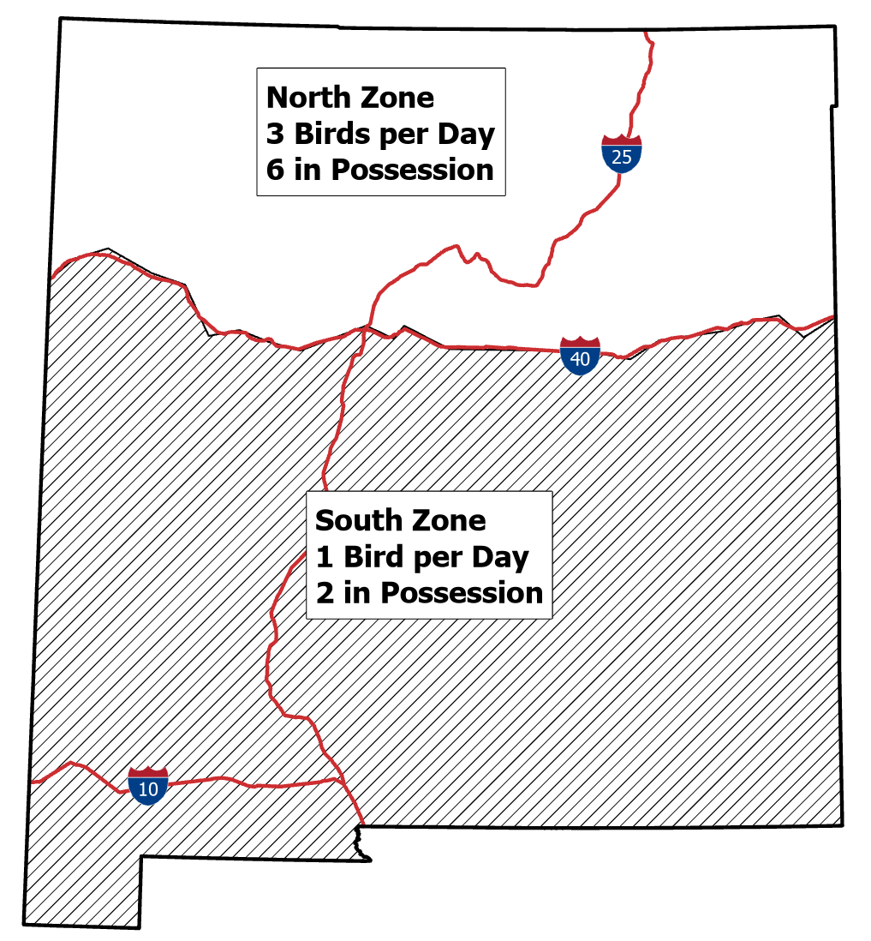

If you would like to comment on the proposals, send email to: [DGF-Gamebird@dgf.nm.gov](mailto:DGF-Gamebird@dgf.nm.gov)