PROPOSED UPLAND GAME RULE SUMMARY, 2026-2030
The upland game rule is amended every four years as part of the upland game rule development cycle. The current 4-year rule expires April 1, 2026. Proposed changes to the rule are made based on findings in scientific literature, data collected by Department staff, and public observations and recommendations.

Proposed amendments include:
- Adjust hunt dates based on calendar dates
- Divide Dusky Grouse into a North and South Zone using I-40 as the dividing line
- Set Bag Limits for Dusky Grouse Zones
  - North Zone- 3 Birds/Day; 6 in possession
  - South Zone- 1 Bird/Day; 2 in possession
- Add an additional special youth pheasant draw hunt on Jackson Lake WMA
- Open Bluebird and Pine River WMAs for upland hunting during squirrel and dusky grouse season
- Open Double E, LBar, Navajo and River Ranch WMAs for upland hunting during quail season

Proposed Dates for 2026-2030:
Species | Zone | Open | Close
Pheasant | Statewide | Dec. 10, 2026 | Dec. 13, 2026
Pheasant | Statewide | Dec. 9, 2027 | Dec. 12, 2027
Pheasant | Statewide | Dec. 7, 2028 | Dec. 10, 2028
Pheasant | Statewide | Dec. 6, 2029 | Dec. 9, 2029

Species | 2026 | 2027 | 2028 | 2029
Middle Rio Grande Valley WMAs Youth-only Pheasant Hunt | Oct.17 | Oct. 16 | Oct. 21 | Oct. 20
W.S. Huey WMA Youth-only Pheasant Hunt | Dec. 5 | Dec. 4 | Dec. 2 | Dec. 1
W.S. Huey WMA Pheasant Hunt | Dec. 12 | Dec. 11 | Dec. 9 | Dec. 8
Jackson Lake WMA Youth-only Pheasant Hunt | TBD | TBD | TBD | TBD

Proposed Changes to Dusky Grouse Zones and Bag Limits:
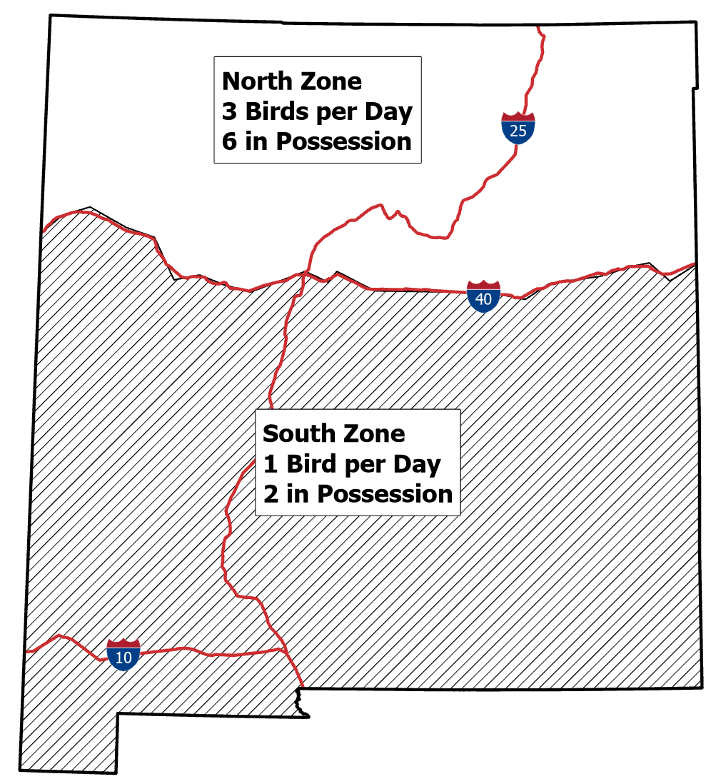

If you would like to comment on the proposals, send email to: DGF-Gamebird@dgf.nm.gov

