PROPOSED UPLAND GAME RULE SUMMARY, 2026-2030
The upland game rule is amended every four years as part of the upland game rule development cycle. The current 4-year rule expires April 1, 2026. Proposed changes to the rule are made based on findings in scientific literature, data collected by Department staff, and public observations and recommendations.

Proposed amendments include:
- Adjust hunt dates based on calendar dates
- Explore changes to the Bernardo Youth Pheasant Hunt to increase R3 opportunities
- Divide Dusky Grouse into a North and South Zone
- Set Bag Limits for Dusky Grouse Zones
  - North- 3 Birds/Day; 6 in possession
  - South- 1 Bird/Day; 2 in possession

Proposed Dates for 2026-2030:
Species | Zone | Open | Close
Pheasant | Statewide  (excluding Valencia County) | Dec. 10, 2026 | Dec. 13, 2026
 |  | Dec. 9, 2027 | Dec. 12, 2027
 |  | Dec. 7, 2028 | Dec. 10, 2028
 |  | Dec. 6, 2029 | Dec. 9, 2029

Species | 2026 | 2027 | 2028 | 2029
Middle Rio Grande Valley WMAs Youth-only Pheasant Hunt | Oct.17 | Oct. 16 | Oct. 21 | Oct. 20
W.S. Huey WMA Youth-only Pheasant Hunt | Dec. 5 | Dec. 4 | Dec. 2 | Dec. 1
W.S. Huey WMA Pheasant Hunt | Dec. 12 | Dec. 11 | Dec. 9 | Dec. 8

Proposed Changes to Dusky Grouse Zones and Bag Limits:
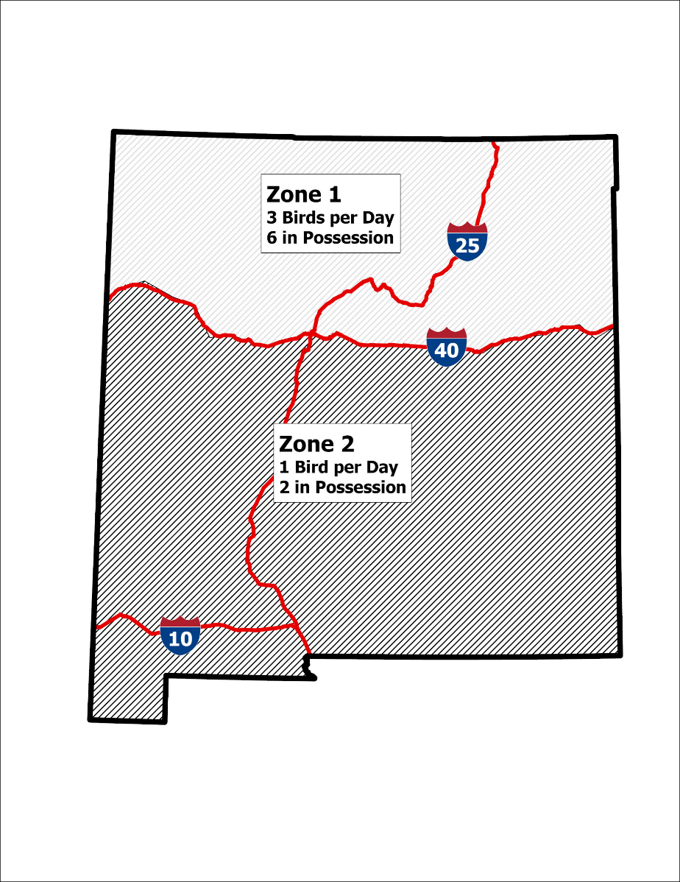

If you would like to comment on the proposal, send email to: DGF-Gamebird@dgf.nm.gov

