Donate to Share with Wildlife and support New Mexico’s native wildlife!
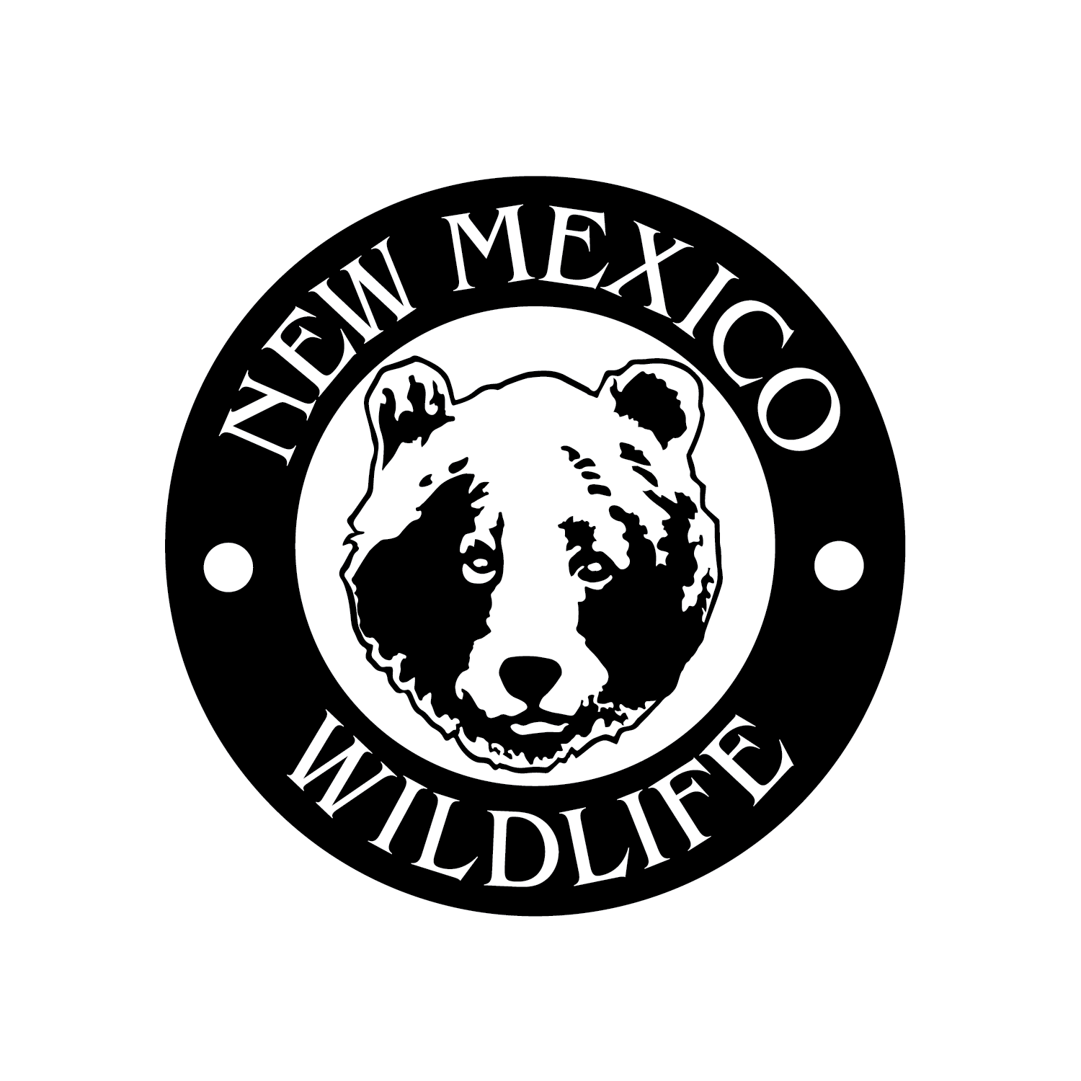
New Mexico’s native wildlife needs your help! The Share with Wildlife program of the New Mexico Department of Wildlife is committed to financially supporting native wildlife conservation and management projects that lack other funding sources in New Mexico.
In particular, the program supports biological and ecological research activities, habitat enhancement efforts, educational programming development, and wildlife rehabilitation facilities that benefit species of conservation concern. Approximately 10 projects are supported during each funding cycle.
The Share with Wildlife program is supported entirely by tax-deductible donations from the public. All donations go directly to supporting projects – no donated funds support program administration.
If you have questions about the Share with Wildlife program, please email the Share with Wildlife Coordinator, Karen H. Gaines (karenh.gaines@dgf.nm.gov).
To make a donation, please fill out the form below and send the form with your check (made payable to “Share with Wildlife”) to the following address:
Karen Gaines, Share with Wildlife Coordinator
New Mexico Department of Wildlife
One Wildlife Way
Santa Fe, NM 87507

Thank you for supporting New Mexico’s native wildlife!

- - - - - - - - - - - - - - - - - - - - - - - - - - - - - - - - - - - - - - - - - - - - - - - - - - - - - - - - - - - - - - - - - - - - -
Share with Wildlife Donation Form (please enclose with your check)

Please accept my contribution of $___________________ to the Share with Wildlife program.

Name: ______________________________________________________________________

Address: ____________________________________________________________________

City: _______________________________________________________________________

State: _________ Zip: ______________

Yes, I would like to receive emailed updates regarding the Share with Wildlife program: ____

Email address: _______________________________________________________________

