November 2025

Dear Middle Rio Grande Valley Youth Sandhill Crane Hunter:

Congratulations, your application was selected for an SCR-0-107 permit to hunt sandhill crane at the Casa Colorada Waterfowl Management Area (WMA) on November 22, 2025. Hunt areas will be randomly selected prior to the hunt, and all sites will be located on land.

You are required to arrive at the WMA by 5:20 am the morning of the hunt. Shooting hours are from one-half hour before sunrise to 1:00 pm. Please ensure that you bring your Special Sandhill Crane Permit, valid hunting license with a Harvest Information Program (HIP) Number, and hunter education certification card. It is required that one adult be present with the youth hunter(s) during this hunt. The adult will be a non-hunter and is present to aid the youth hunter.

The bag limit is three (3) sandhill cranes and only nontoxic shells are allowed. Harvest information will be gathered at the check station at the conclusion of your hunt. The check station will be located near the entrance to the WMA (see attached map).

Good luck on your hunt.

Migratory Game Bird Program
New Mexico Department of Game and Fish

Casa Colorada WMA

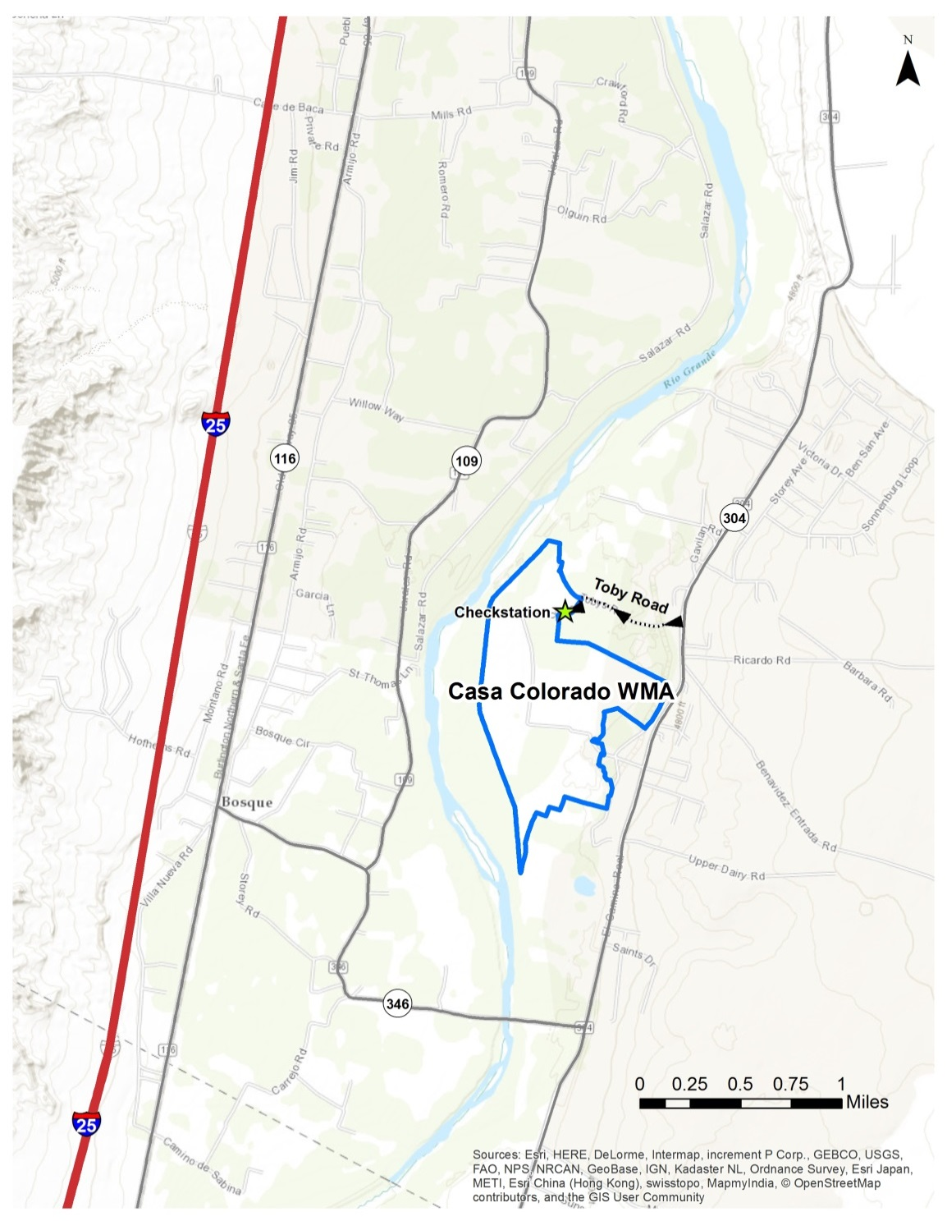
© OpenStreetMap Contributors, ERSI, and GIS User Community

Directions to Casa Colorada WMA:

From Belen: go east on Reinken Ave. (NM-309) towards Rio Communities
Turn slightly right onto NM-47
Turn right onto NM-304 and drive south approximately 6.5 miles to Casa Colorada
Turn right onto Toby road towards Casa Colorada WMA entrance, approximately ½ mile

From Bernardo: drive east on U.S. 60 approximately 3 miles
Turn left onto NM-304 (intersection for NM Boys Ranch and the town of La Joya)
Drive approximately 11.5 miles north to Casa Colorada
Turn left onto Toby road towards Casa Colorada WMA entrance, approximately ½ mile


2025 MRGV YOUTH-ONLY SANDHILL CRANE HUNT HARVEST SURVEY, SCR-0-107 (Casa Colorada)

Please complete the appropriate portion of this questionnaire whether or not you hunted.

NAME:___________________________________ PERMIT NUMBER:_____________

Hunt Date | How many hours did you hunt? | Number of cranes killed | Number of cranes  dropped but NOT  RETRIEVED | Total number of shots fired
Nov. 22

Comments: ____________________________________________________________
________________________________________________________________________
________________________________________________________________________

Please turn in this harvest survey at the check-station at the end of your hunt.

If you are unable to attend the hunt, please return this harvest report within 5 days from the close of the hunt to: NM Dept. of Game & Fish – Sandhill Crane Surveys, One Wildlife Way, Santa Fe, NM 87507 or DGF-Waterfowl@state.nm.us

