December 2025

Dear Sandhill Crane Hunter:

Congratulations, your application was selected for a permit to hunt Sandhill Cranes during the 2026 New Mexico Middle Rio Grande Valley (MRGV) special season, SCR-0-105. Your hunt is scheduled for January 3–4, 2026. The MRGV hunt area includes Socorro and Valencia counties only. The daily bag limit is three (3) cranes with six (6) in possession. Shooting hours are from one-half hour before sunrise to sunset and only non-toxic shot may be used and in possession of the hunter.

If you are successful in bagging any cranes, you are required to stop by the check station to have your cranes examined by a biologist (see attached map for location). The biologist will take measurements to determine if your crane is a greater sandhill crane. The Department is required to monitor the number of greater sandhill cranes harvested to ensure we do not exceed a sustainable harvest. A map to Bernardo WMA and directions to the check station are included with this letter. The check station will be open from 7:45 am to 7:15 pm on Saturday and Sunday.

Please do not clean your cranes prior to bringing them to the check station. It is critical that all harvested cranes are brought to the check station, as any cranes not checked at the station must go towards the state’s harvest allotment for greater Sandhill Cranes. This may result in having to close crane hunts if it appears that New Mexico will exceed its allotment. If you do not hunt or do not bag any cranes, you are still responsible for filing a harvest report by January 12, 2026 via the Department’s online licensing system or by calling 888-248-6866.

IMPORTANT–If you harvest cranes, you must bring your cranes to the check station. You must also file a required harvest report by January 12, 2026. If you did not hunt or did not harvest any cranes, you still must file a required harvest report by January 12, 2026.

A valid hunting license with a Harvest Information Program (HIP) Number, and a hunting permit issued for the correct date and hunt location are required to participate in this hunt. Hunters 17 years of age or younger must also possess their hunter education certification card.

Migratory Game Bird Program
New Mexico Department of Game and Fish

Bernardo Sandhill Crane Check Station Map
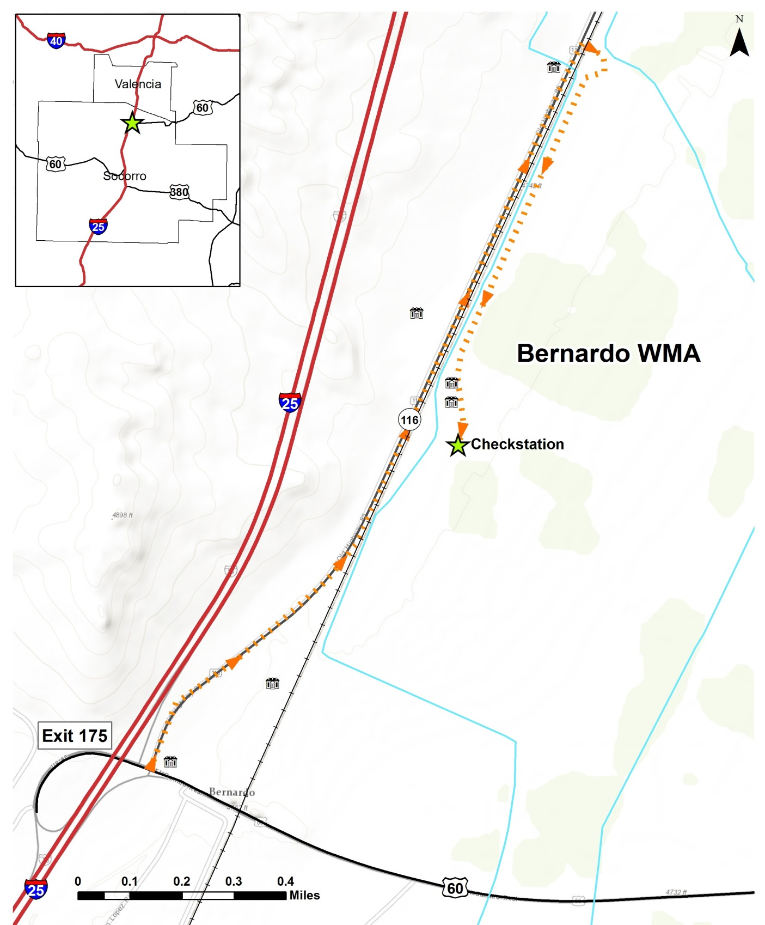
© OpenStreetMap Contributors, ERSI, and GIS User Community

Directions:
- Take I-25 to US-60 East, Exit Number 175, toward Bernardo/Mountainair
- Turn north on NM-116, on the east side of the interstate and drive for 1.5 miles
- Turn right into the Bernardo WMA, cross the railroad tracks, and immediately turn right
- Drive south 0.8 miles, past the two houses to the large shop building

