
Technical Information for Migratory Game Bird Rule Development

Survey and Harvest Data

Migratory game bird management in the United States, including New Mexico, is a cooperative effort between state and federal governments. Management decisions are based on information gathered from bird population surveys, monitoring of harvest, hunter surveys, public comment, biological information, and environmental surveys. Migratory game bird banding and recovery data, surveys of birds on their breeding areas, as well as wetland condition surveys in waterfowl breeding areas provide the necessary information used to set hunting and harvest regulations for migratory game birds. In New Mexico, the establishment of migratory game bird hunting rules and regulations remains a cooperative process performed annually within the Flyway system. Both the Central and Pacific Flyways are involved in setting hunting regulations for migratory game birds in New Mexico and seasons are selected from within the guidelines of the U.S. Fish and Wildlife Service’s federal season frameworks. Survey and harvest data used in setting hunting rules and regulations for New Mexico are included in Figures 1–4.
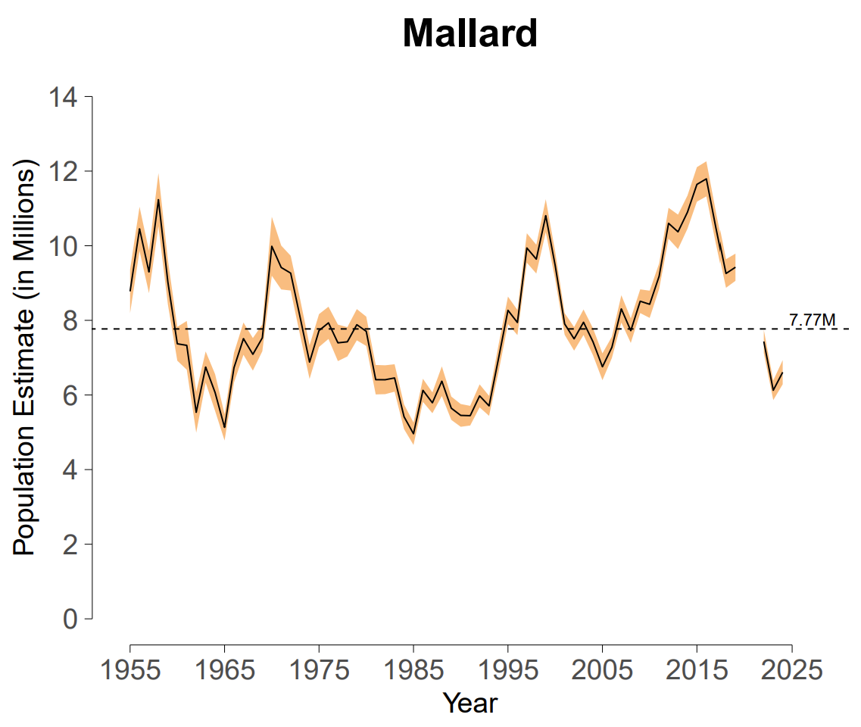
Figure 1. Breeding population estimate, 90% confidence interval, and North American Waterfowl Management Plan goal (dashed line) for mallards in the traditional survey area. Estimated mallard abundance for 2024 was 6.6 ± 0.3 million.

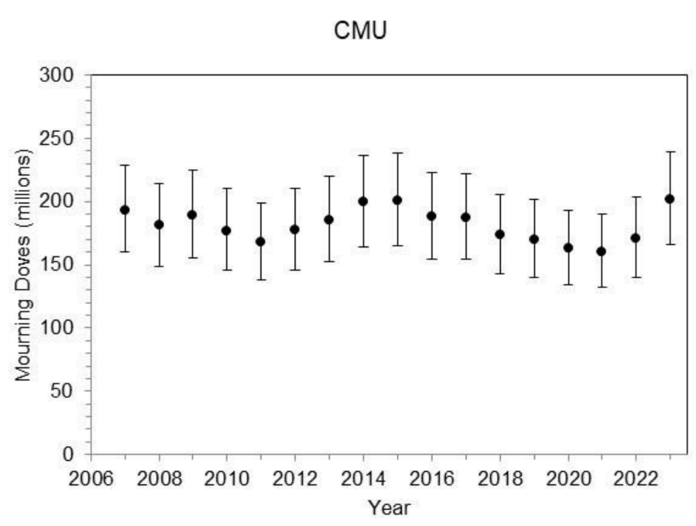

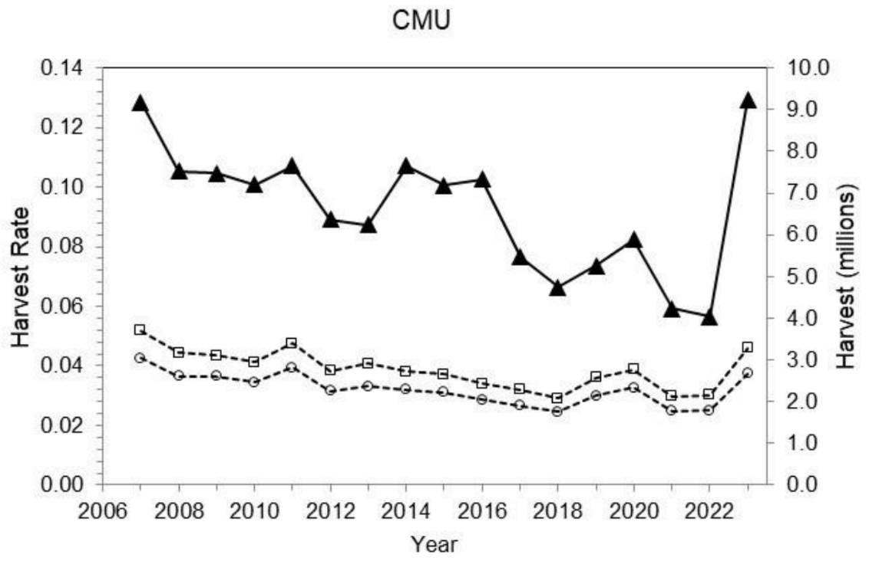
Figure 2. Estimates and 95% confidence intervals of mourning dove absolute abundance from an integrated population model. Figure shows abundance estimates for the Central Management Unit (CMU; which includes New Mexico) by year, 2007–2023. Estimates are based on band recovery, breeding bird survey indices, and harvest survey data.

Figure 3. Estimated harvest (triangle) and harvest rates of mourning dove in the Central Management Unit (CMU; which includes New Mexico) by year, 2007–2023. Harvest rates are presented separately for hatch-year (square) and after-hatch-year (circle) doves.
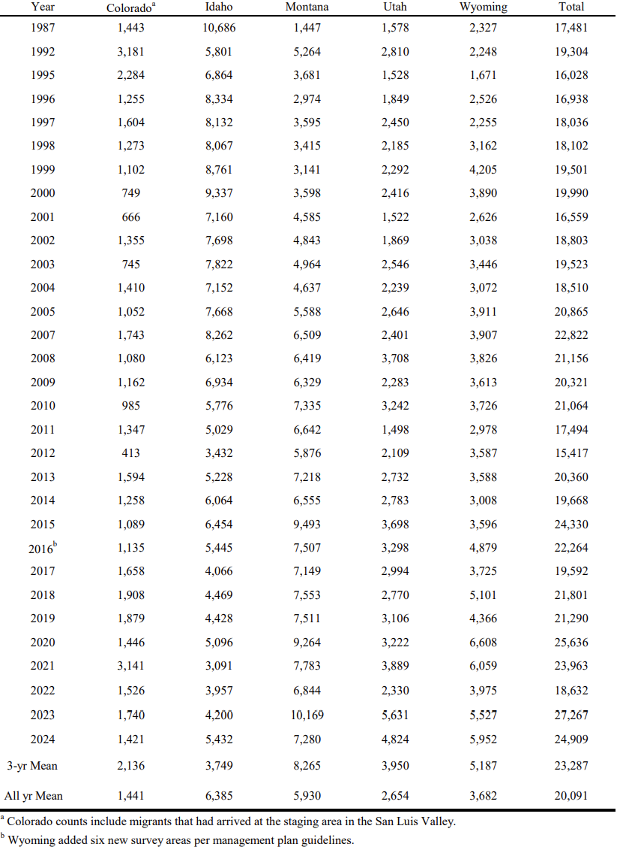
Figure 4. Fall pre-migration indicies for Rocky Mountain sandhill cranes.

