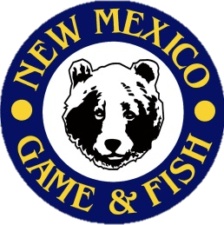
0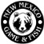
What do I need for class:

- Obtain a copy of the bowhunter education student manual at www.bowhunter-ed.com/newmexico/ OR by picking up a hardcopy at (location).
- Complete worksheets from the student manual. Worksheets can be printed from the website listed above OR completed on pages 77-80 in the back of the hardcopy student manual.
- There are no fees associated with the course; however donations may be offered to the volunteers’ to help offset out-of-pocket expenses they incur to put on the course.
- Archery equipment. We will provide equipment if you do not have your own.
- Bring a sack lunch, snacks and drinks.

Course Location:
Facility address, city & zip
Bowhunter Education Course
New Mexico Department of
Game & Fish
Hunter Education
7816 Alamo Rd.
Albuquerque, NM 87120
Ph: (505) 222-4731
www.wildlife.state.nm.us
Special Notes

- Student worksheets must be 100% complete prior to the first class session or students will not be allowed to participate in the course (no exceptions).
- You MUST attend all course sessions. Students arriving late will not be permitted into class.
- Students under the age of 11 must be accompanied by an adult at all times during class

If you are unable to attend, please log onto your CIN account and drop the course, or call the Hunter Education Office at (505)222-4731.

Course Schedule:

Date
Day Times

Course Contact:
Instructor Name
Phone number

NEW MEXICO DEPARTMENT OF GAME & FISH STUDENT INFORMATION SHEET

